Lesson 9.2 Distance and displacement

Recommended teaching time for this lesson: 1 x 60 minute period

• 35 minutes of explicit teaching

• 25 minutes of suggested classroom activities

• 30 minutes homework

Getting started

Key ideas

* Distance describes the total length of the pathway taken between the origin and the destination point; a scalar quantity.
* Displacement describes change in position in a given direction and is a vector quantity.
* Two or more vector quantities can be added to produce a single resultant vector.
* Vector quantities can also be subtracted. Change in a vector measurement means subtraction.
* Multiplication of a vector (magnitude + direction) by a scalar (magnitude) will change the magnitude of the vector but will leave its direction unchanged.

Curriculum links

Science understanding

* Calculate resultant vectors through the addition and subtraction of two vectors in one dimension.
* Describe the concepts of displacement, velocity and acceleration.

Advice for teaching this lesson

Things to know before you start teaching

Distance versus displacement is the initial fundamental concept for a large amount of this unit, most other values are going to be defined in relation to the change of these measurements. Helping students understand these concepts by definition and description, by representation, and by physically acting it out will set a strong foundation.

Common misconceptions

* Students often mix up the symbols for distance and displacement. An easy way to remind them is ‘*d*’ for distance, ‘*i*’ for imaginary number, ‘*s*’ comes next. They may also come across using *‘*x’ as notation for displacement; this is often used at university.

Differentiation strategies

Get students to practice with visual representations of vectors doing simple 1D vector sums as these often feel very ‘common sense’ to the point that it can be confusing as to ‘why’ students need to do these sums. With 2D vectors students generally do not object to the process of setting out their mathematics for solving these questions, as they are more difficult to solve intuitively. However, students who struggle with algebra will find that solving 2D vector problems with a drawing approach is very simple, but they will need the practice now.

Starter activity: How far away am I?

Approximate time: 5 minutes

**Activity placement:** Place directly after Lesson overview

**Activity summary:** A physical activity to get students thinking about what language means ‘physically’.

Notes for the teacher

This works best if you are comfortable climbing over desks, but consider workplace health and safety.

You could prepare for this by acquiring a tape measure or metre ruler.

Getting students to give you their responses and then trying to act it out can be beneficial for getting students to recognise that common language does not always match mathematical definitions.

When a student says they are a ‘walking’ distance away from you or the board, get them to act it out, and then ask if there are other ways to do it.

Instructions for students

Step 1: Your teacher may volunteer to be the subject for this activity. You should encourage them to do so.

* 1. State how far away the whiteboard is.

Step 2: Attempt to measure out the distance, or your teacher will measure the distance for you.

* 1. Describe the two ways you could measure how far away something is.

Answers

1. Student answers will vary but should be reasonable. Answers should be given in metres.
2. You could measure the path taken to get to the whiteboard by avoiding other objects like the desks and chairs. You could measure the amount of space in a straight line between you and the whiteboard.

Classroom activity: Distance vs displacement

Approximate time: 10 minutes

**Activity placement:** Place directly above “How do you add vectors?”

**Activity summary:** A summary activity to compare and contrast fundamental terminology.

Notes for the teacher

Encourage students to use the margin notations of the module to help with their critical features of terminology.

Get students to refer back to the first two points of the ‘key ideas’ to check their work.

Instructions for students

Draw a two-circle Venn diagram. Label the two circles ‘Distance’ and ‘Displacement’.

1. Annotate your Venn diagram with similarities and differences of the two terms to create a summary of the two concepts.

Helpful hints

* The margin annotations in Lesson 9.2, and the key ideas at the start of the module will help give you important information.

Support activity

Notes for the teacher

This version will directly tell the students what items to add to their circles.

Instructions for students

Draw a two-circle Venn diagram. Label the two circles ‘Distance’ and ‘Displacement’.

1. Annotate your Venn diagram with similarities and differences of the two terms to create a summary of the two concepts. You should include the symbols, the units, and a small statement about what they measure.

Challenge activity

Notes for the teacher

This version will encourage students to consider idiomatic expressions like “as the crow flies” to add to their diagrams.

Instructions for students

Draw a two-circle Venn diagram. Label the two circles ‘Distance’ and ‘Displacement’.

1. Annotate your Venn diagram with similarities and differences of the two terms to create a summary of the two concepts.
2. Add an idiomatic expression to summarise your concepts to each circle. An idiom is a non-literal saying like “throw the baby out with the bathwater” meaning to throw out the valuable thing along the waste.

Answers

1. 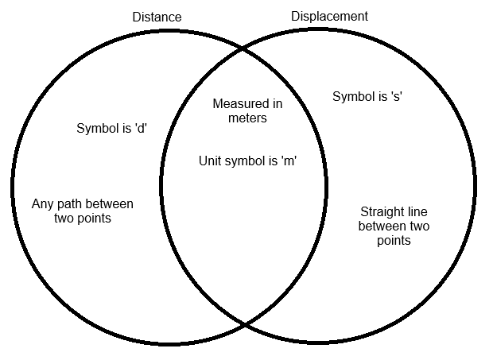

Support activity

1. 

Challenge activity

1. Idioms can vary. Example given.

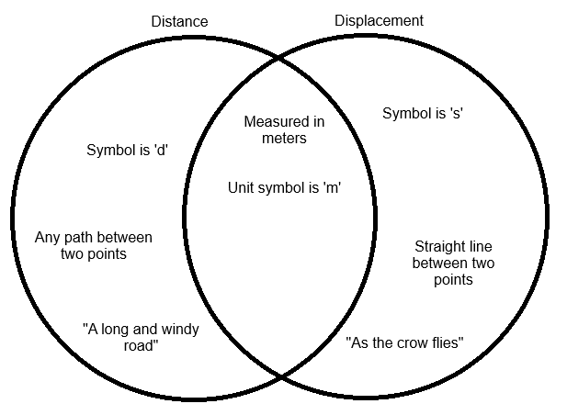

Classroom activity: Combining three vectors

Approximate time: 10 minutes

**Activity placement:** Place directly above “How do you multiply vectors”

**Activity summary:** Getting students to graphically and mathematically practice with three vectors.

Notes for the teacher

Encourage students to follow the rules of vector addition and subtraction from earlier in the lesson strictly, especially for graphical approaches.

Instructions for students

For the following vector sentence, calculate the total displacement using the following methods:

A student walks 15 m in a straight line, pauses to talk to some friends. They then walk another 20 m, before being called back to talk with a teacher who is 5 m behind them.

1. Solve the vector sentence using mathematical sums.
2. Solve the vector sentence using graphical means.

Helpful hints

* Examine Case 1 and 2, as well as Worked example 9.2A to see how to draw the vectors.

Support activity

Notes for the teacher

This method removes the negative vector for another positive vector. You should work with the student on the core activity.

Instructions for students

For the following vector sentence, calculate the total displacement using the following methods:

A student walks 15 m in a straight line, pauses to talk to some friends. They then walk another 20 m, before being running ahead to line up at class 10 m in front of them.

1. Solve the vector sentence using mathematical sums.
2. Solve the vector sentence using graphical means.

Challenge activity

Notes for the teacher

This method introduces a 2D vector sum and changes the sequence of questions to attempt the graphical version first. Students should be encouraged to measure the length and angle of their drawn shape before solving using Pythagoras’ theory and trigonometry for question b.

Instructions for students

For the following vector sentence, calculate the total displacement using the following methods:

A student walks 15 m in a straight line, pauses to talk to some friends. They then walk another 20 m, before jogging 15 m to the left to line up at the tuck shop.

1. Solve the vector sentence using graphical means. Make sure to measure your final answers, do not calculate them.
2. Solve the vector sentence using mathematical sums.

Answers

$\overset{⃑}{s}=15+20+ -5=30 m$

1. Answer should be drawn to scale, e.g. 1 m per cm, or 5 m per cm.

Support activity

$\overset{⃑}{s}=15+20+10=45 m$

2. Answer should be drawn to scale, e.g. 1 m per cm, or 5 m per cm.

Challenge activity

